**Microprocessor Lab**

Laboratory Activity No. 1

**Familiarization with TinkerCAD**

|  |
| --- |
|  |

Score

*Submitted by:*

**Mui, Marc Jefferson T.**

**Saturday 4PM-7PM / CpE 412-2**

*Date Submitted*

**16-09-2023**

*Submitted to:*

**Engr. Maria Rizette H. Sayo**

1. Exercise

a. A process in Tinkercad where we can develop electronic circuits that can be quickly updated, modified and tested is called **prototyping**.

b. In Tinkercad, **simulation** tests the working of the circuits and the components.

c. The device used to assemble and connect the various components is known as **breadboard**.

d. In an electronic circuit with LED, the positive end of the circuit should be connected to

**anode** and negative end should be connected to **cathode** of the LED.

e. A **resistor** is used to restrict the flow of current to electrical components

2. Label the following:

1. Anode and Cathode in a LED



Anode

Cathode

1. Different parts of breadboard

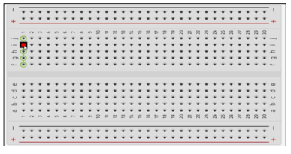

Edge

Main Area

Edge

1. List the electronic components used in a circuit assembly

* Battery
* Resistor
* Capacitor
* LED (Light Emitting Diode)
* Potentiometer
* Switch
* Diode
* Push Button